U18CO018

Shubham Shekhaliya

MIT

Assignment-8

Programming in 8086

1-> Write 8086 ALP for addition of two 8-bit numbers.

**Code:-**

**model small**

**.data**

**ca db ?**

**p1 db ?**

**p2 db 80H**

**p3 db 44H**

**.code**

**mov ax, @data**

**mov ds, ax**

**mov cl, 00H**

**mov al, p2**

**add al, p3**

**jnc skip**

**inc cl**

**skip: mov p1, al**

**mov ca, cl**

**mov ax, 4C00H**

**int 21h**

**end**

**Output:-**

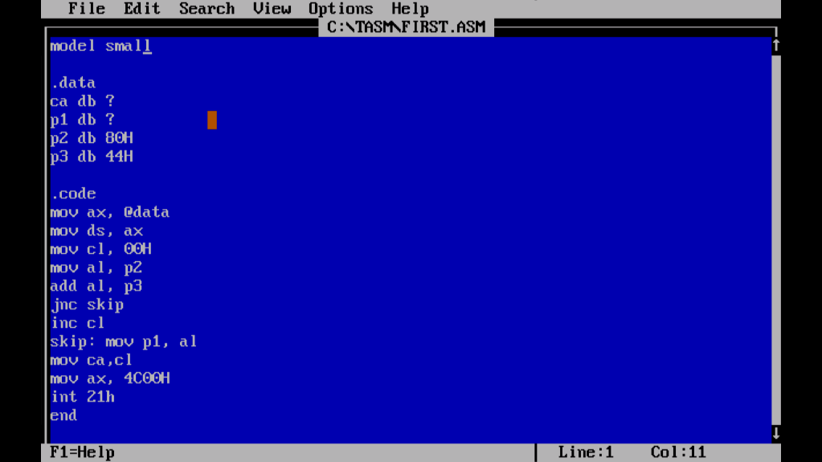

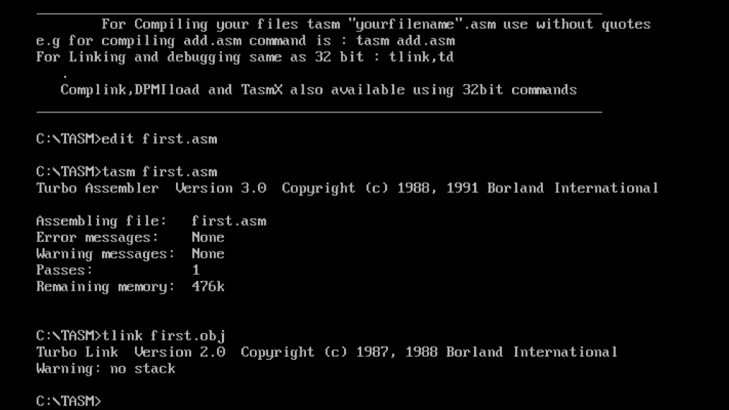

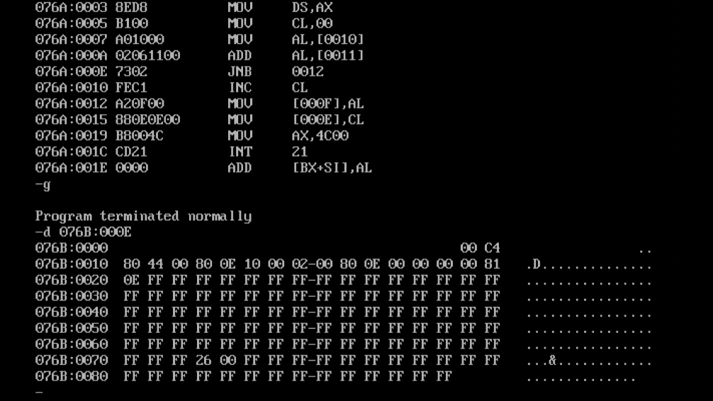

**2->** Write 8086 ALP for subtraction of two 8-bit numbers.

**Code:-**

**model small**

**.data**

**ca db ?**

**p1 db ?**

**p2 db 42H**

**p3 db 44H**

**.code**

**mov ax, @data**

**mov ds, ax**

**mov cl, 00H**

**mov al, p2**

**sub al, p3**

**jnc skip**

**inc cl**

**skip: mov p1,al**

**mov ca, cl**

**mov ax, 4C00H**

**int 21h**

**end**

**Output:-**

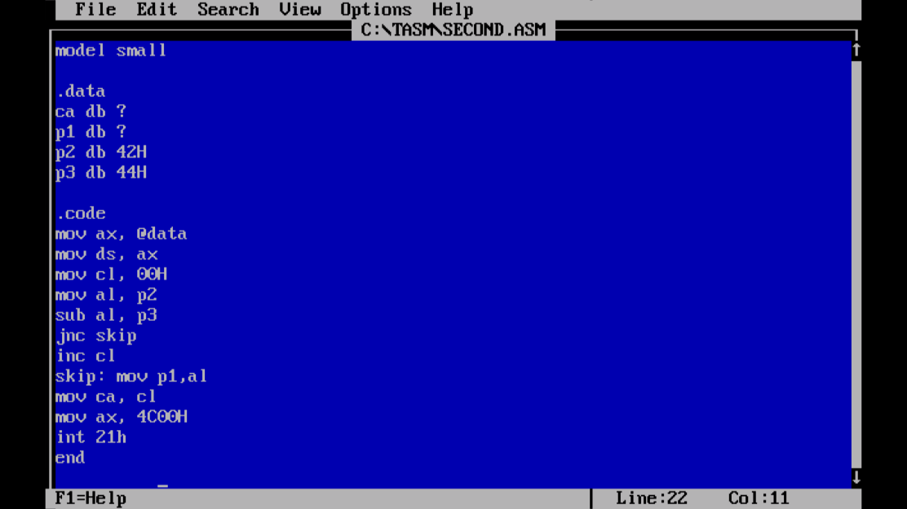

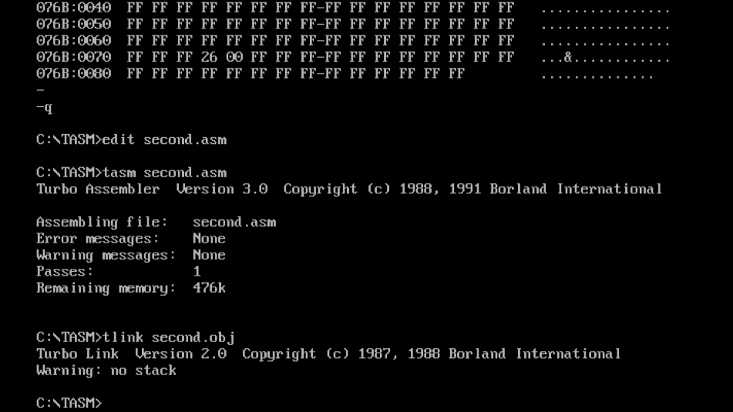

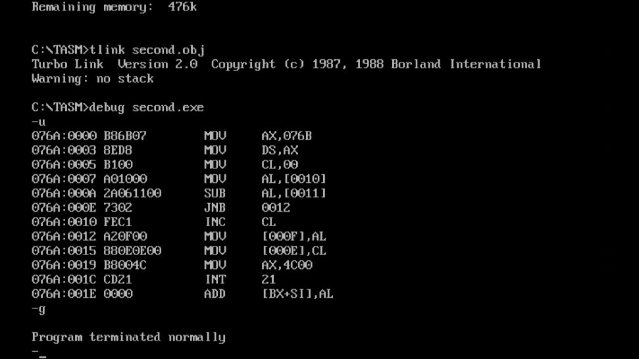

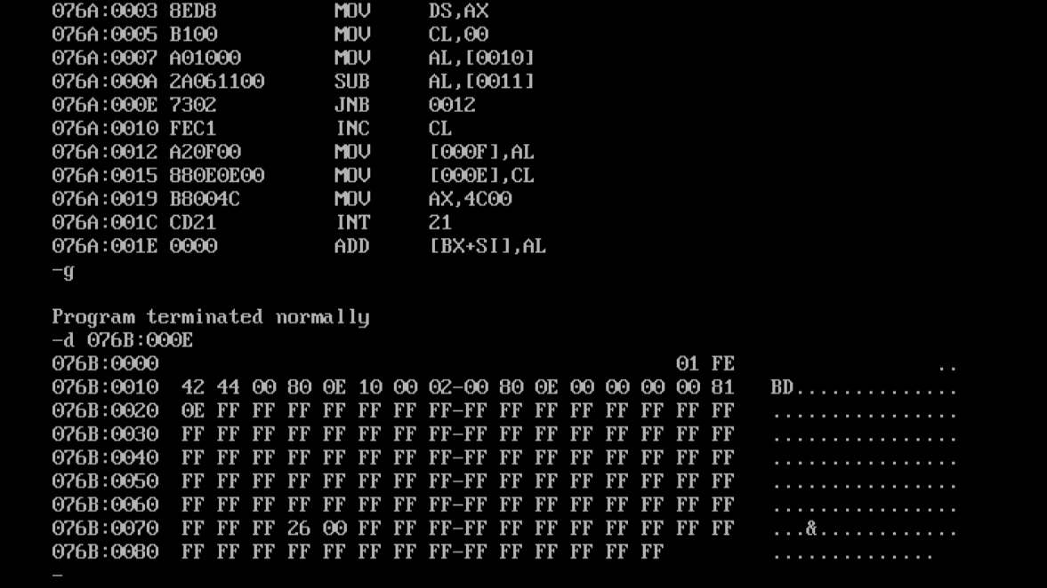

**3->** Write 8086 ALP for addition of two 16-bit numbers

**Code:-**

**model small**

**.data**

**ca db ?**

**p1 db ?**

**p2 db ?**

**p3 db 41H**

**p4 db 42H**

**p5 db 61H**

**p6 db 62H**

**.code**

**mov ax, @data**

**mov ds, ax**

**mov cx, 0000H**

**mov ah, p3**

**mov al, p4**

**mov bh, p5**

**mov bl, p6**

**add ax, bx**

**jnc skip**

**inc cx**

**skip: mov p1, ah**

**mov p2, al**

**mov ca, cl**

**mov ax, 4C00H**

**int 21H**

**end**

**Output:-**

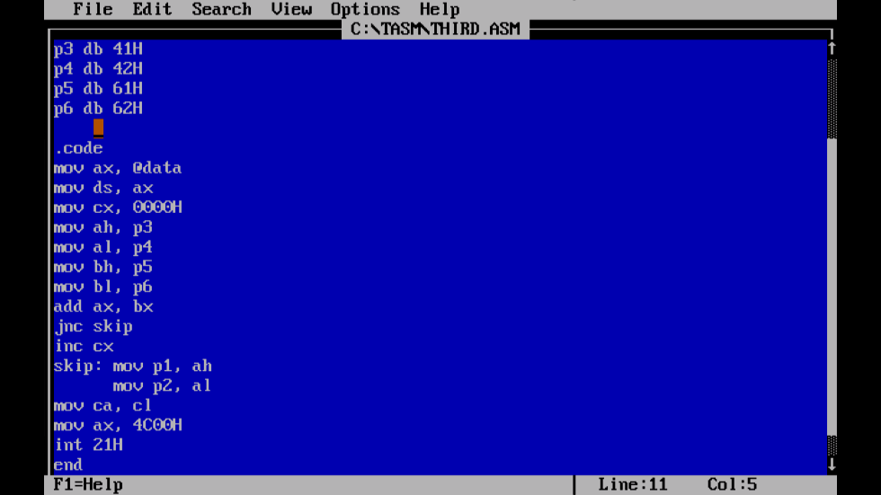

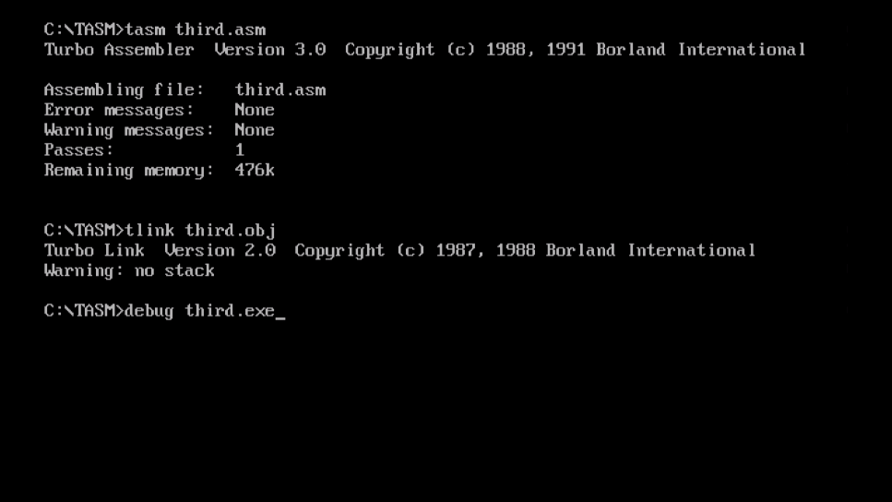

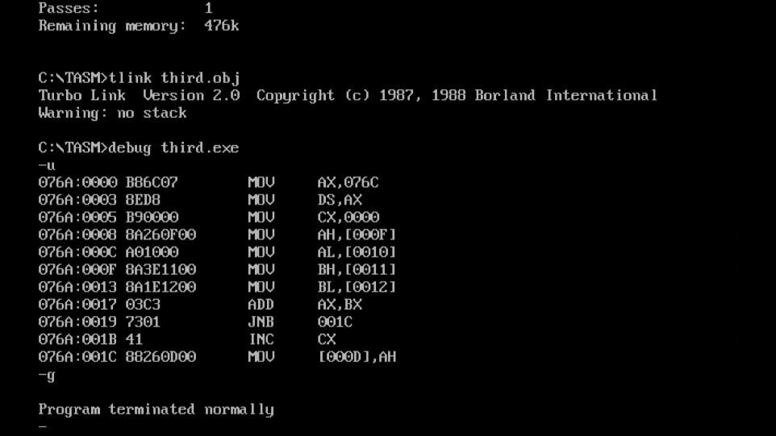

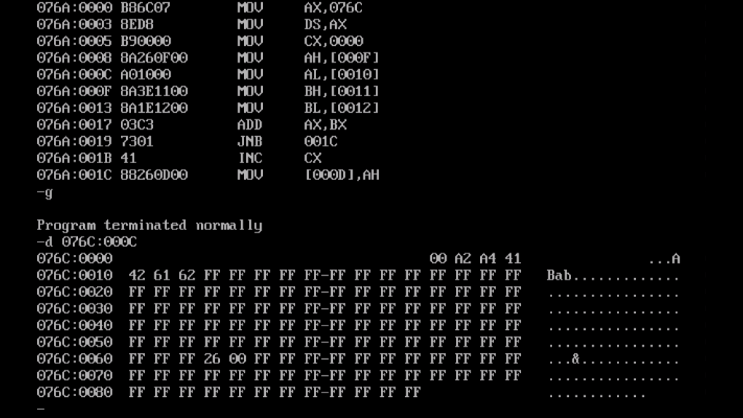

**4->** Write 8086 ALP for subtraction of two 16-bit numbers

**Code:-**

**model small**

**.data**

**ca db ?**

**p1 db ?**

**p2 db ?**

**p3 db 65H**

**p4 db 67H**

**p5 db 48H**

**p6 db 32H**

**.code**

**mov ax, @data**

**mov ds, ax**

**mov cx, 0000H**

**mov ah, p3**

**mov al, p4**

**mov bh, p5**

**mov bl, p6**

**sub ax, bx**

**jnc skip**

**inc cx**

**skip: mov p1, ah**

**mov p2, al**

**mov ca, cl**

**mov ax, 4c00H**

**int 21h**

**end**

**Output:-**

